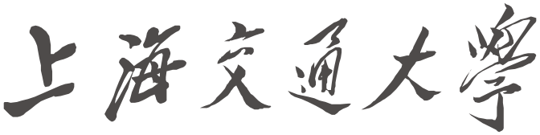

学生实习报告

实习题目: Text Recognition via OCR
实习单位: 上海交通大学
实习时间：2023-06-19 至 2023-07-14
学院(系): 电院自动化系
专 业: 自动化
学生姓名: JOONGWON CHAE 学号: 518030990043

2023年 7 月 17日

SHANGHAI JIAO TONG UNIVERSITY 学生实习报告用纸

实习报告主要内容包括实习目的与任务、实习单位、实习内容、实习收获等
OCR and image processing project report

1. Introduction
Over the past four weeks, I conducted a practical exercise on deep learning and image processing. The greatest achievements during this process included the enhancement of debugging skills, a mathematical understanding of existing image processing algorithms, and the mastery and learning of new deep learning structures and techniques. The main content of the practice was to extract text using OCR (Optical Character Recognition) and create CSV files. The final goal was to complete image processing within 30 seconds.

2. Practice Process
The practice was carried out in the following three stages.

2.1. Initial Attempt using YOLO
Initially, we explored the potential for text extraction based on YOLO. We used YOLO to create pt files and used them to create bounding boxes. However, there were problems such as YOLO taking too long to detect more than 100 boxes at once, and needing nearly 1000 bounding box detections to detect combinations of characters and numbers consisting of 8 digits. There were unsolvable issues like overlapping bounding box regions, long detection time due to a large number of box detections, and errors occurring when text detection failed. Despite attempts to improve this by debugging and adjusting various parameters like anchor boxes and batch size, the problem was not solved, so we decided to use OCR open source for processing.

2.2. Study on OCR and Deep Learning Structure
We studied various deep learning-based OCR tools, including Naver's EasyOCR and Baidu's PaddleOCR, to apply OCR. During this process, we studied image preprocessing techniques such as Affine and Perspective, applied them, and increased the text recognition rate from 70% to 80%. Additionally, we also learned about deep learning structures like VGG16 and U-Net and implemented them.

2.3. Application and Optimization of PaddleOCR
Due to the unsatisfactory performance of Naver's EasyOCR, we decided to apply Baidu's PaddleOCR. We used PaddleOCR to extract text from images, and the text recognition rate reached 94%. Various image preprocessing techniques were applied, including Threshold, adaptive threshold, canny edge, shadow removing, and perspective. However, there were problems where the recognition rate decreased when applying other techniques. Ultimately, we confirmed that images with Perspective applied were the most effective.

Thereafter, while the recognition rate of the image was good, the instability of the algorithm that automatically finds Perspective was an issue. It was because the algorithm finding the contour through the edge of the image was affected by the amount of light and changes in angles, which influenced the performance of Perspective. To solve this, we tried to find the edges of the image using YOLO, but failed to find the feature points.

Afterwards, we assigned black stickers and cross-shaped features to the edges of the boxes to be detected and applied Perspective using Template Matching, and then conducted OCR based on this. However, the problem of template matching being sensitive to light and angle kept occurring, and edge detection through perspective transform failed when slight condition changes occurred. Finally, we conducted feature matching and successfully performed edge detection under various conditions.

During this process, we created a GUI and added functions to take pictures with a camera, perform OCR extraction, and create CSV files. However, there was a problem where multithreading did not occur simultaneously from the camera. To solve this, we modified the code so that when the button is pressed, pictures can be taken sequentially from two cameras and displayed on the UI. This was an instance where we could understand why C# and C++ are used more often than python in UI creation.

3. Conclusion
Through practice, we improved debugging skills and conducted mathematical learning on image processing algorithms. This allowed us to understand how mathematical knowledge can assist when coding. We also mastered and learned new deep learning structures and techniques. In particular, we successfully extracted text using OCR technology and converted it into CSV files. However, the processing speed was slower than expected. This was due to the performance limit of the CPU and the decrease in recognition rate when reducing image size. We expect this problem can be solved by using a GPU or high-performance CPU.

During this project, the advancement of AI was truly astonishing. I used CHAT GPT4 and Github Copilot, which allowed me to design algorithms easily based on ideas.

The main takeaway from this project was that AI is not a panacea but should be used as a tool. To use AI proficiently, the user's basic knowledge is critically important. AI can write code proficiently based on user commands and find problems, but if the user does not understand the functions of the library and does not give detailed commands, it cannot produce satisfactory results.

The development of China's AI technology was also very surprising. After conducting research using all three of Tesseract, EasyOCR, and Paddle, Paddle's basic performance was truly astonishing. It showed better performance than custom-trained Tesseract and EasyOCR. It was also well-customized under various conditions, there were many materials in Chinese, and the quality of the materials was good.

Considering that the most important skill when coding is finding ideas and materials, I believe English and Chinese have become essential elements for programmers.
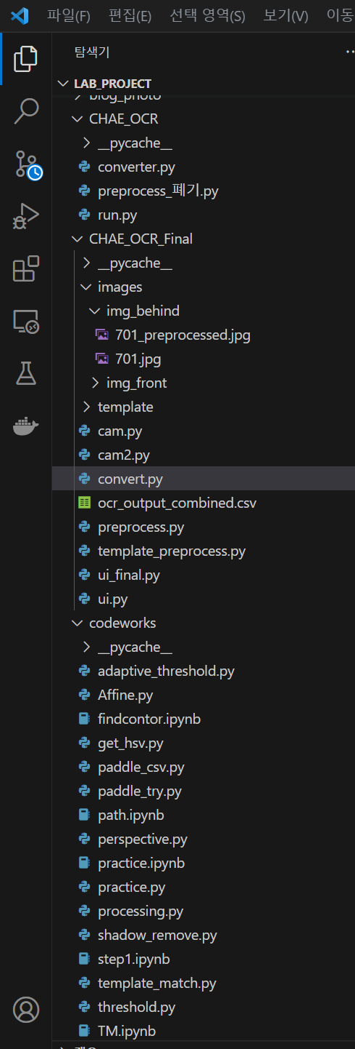
Figure 1. studied Algorithms
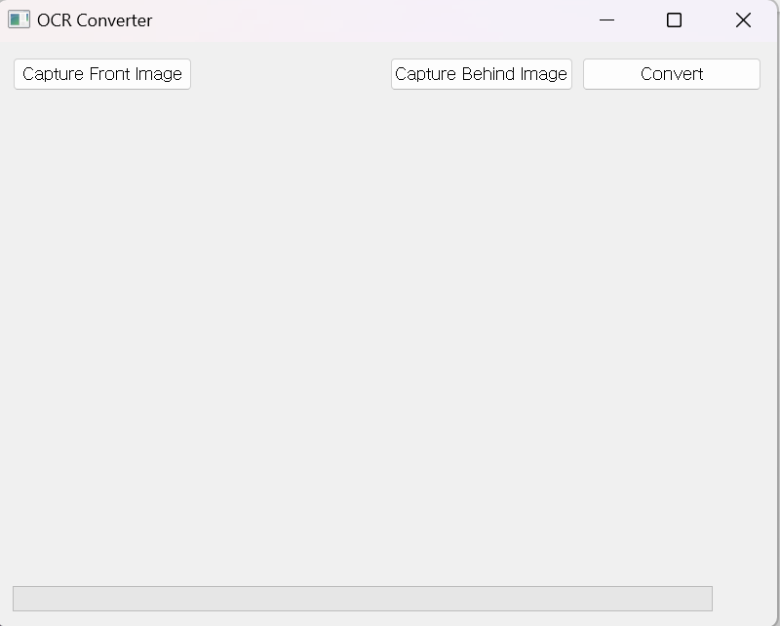
Figure 2. UI Design
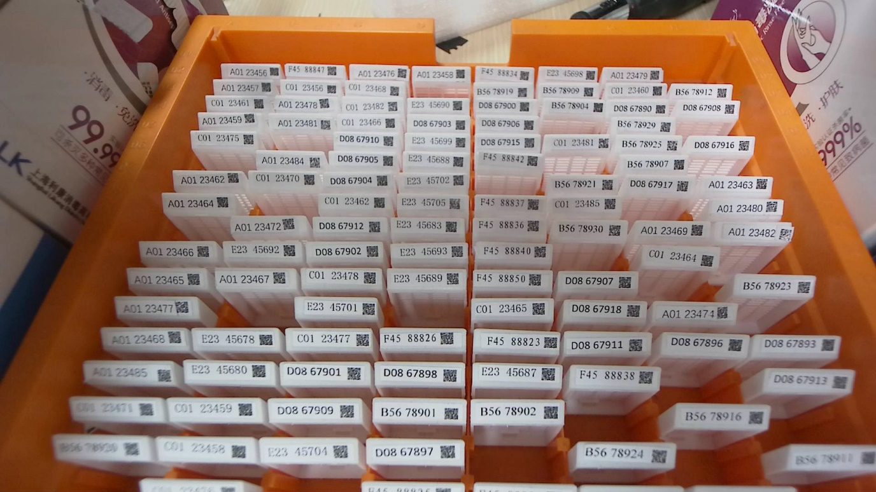
Figure 3. Image before preprocessing
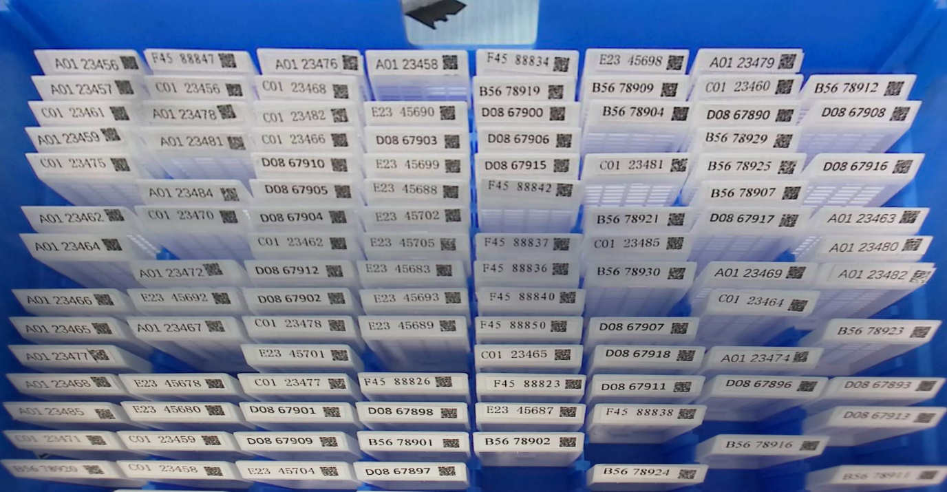
Figure 4. Image after preprocessing

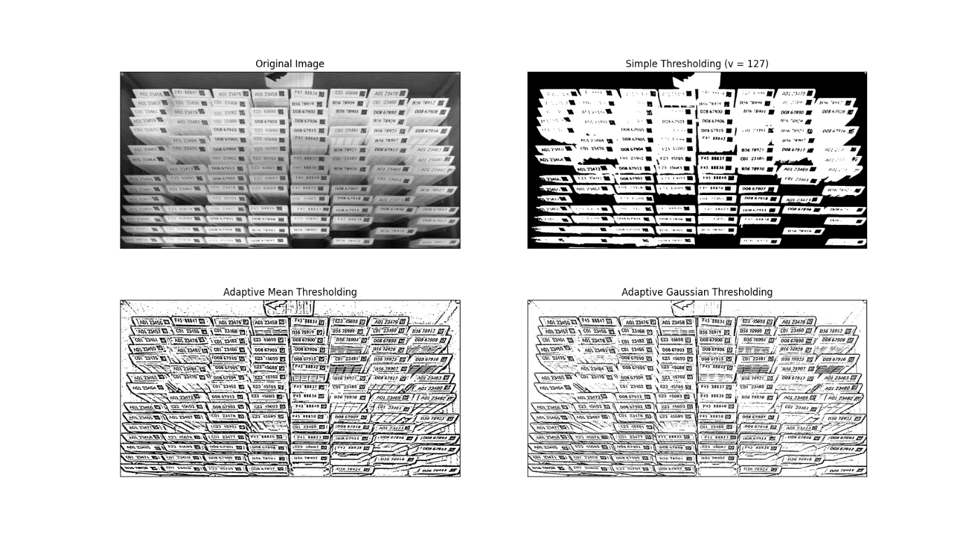
Figure5. Algorithms for bad results

SHANGHAI JIAO TONG UNIVERSITY 学生实习报告用纸

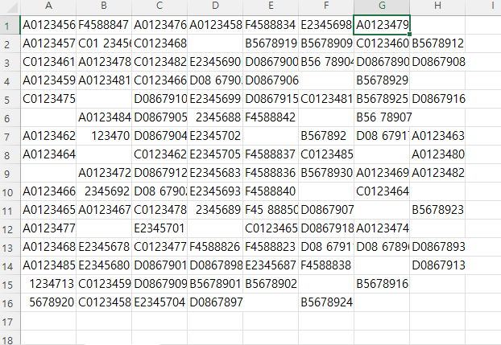
Figure6. results

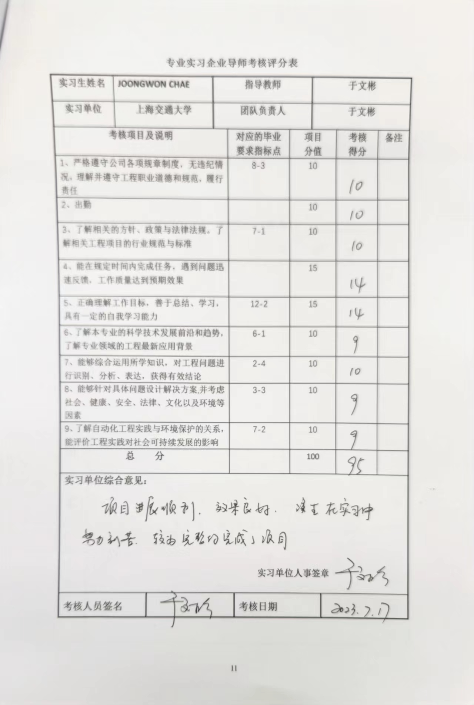
专业实习企业导师考核评分表
实 习 报 告 评 阅 人 意 见 | 评阅人（签名）：  年 月 日
系 主 任 意 见 | 评 定 成 绩 ：________________  系 主 任(签名)：________________  年 月 日

